Copyright for test papers and marking guides remains with West Australian Test Papers.
Test papers may only be reproduced within the purchasing school according to the advertised Conditions of Sale.
Test papers should be withdrawn after use and stored securely in the school until Friday 14th June 2019.



MATHEMATICS
METHODS
UNIT 3

Semester One

2019

SOLUTIONS

Calculator−free Solutions
1. (a) 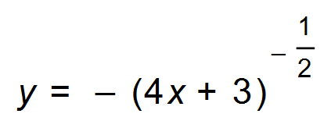
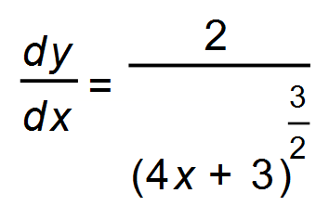
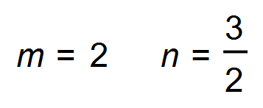
(b) 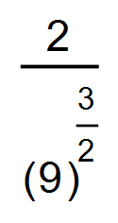
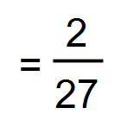 [3]

2. (a) 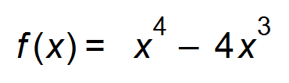
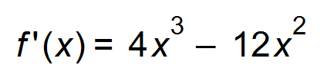
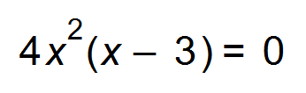
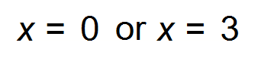
Stationary points (0, 0) and (3, $-$ 27)
(b) 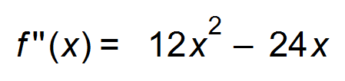
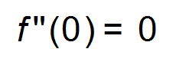∴ horizontal point of inflection occurs at (0, 0)
(3, −27)
(c) (i) 
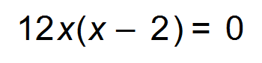
∴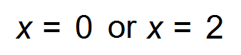
Point of oblique inflection at (2, $-$16)
(ii) m = $-$16
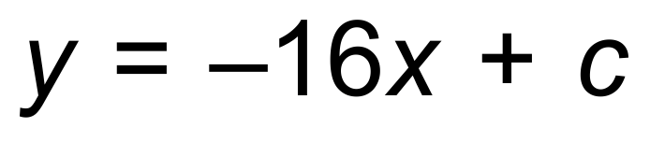
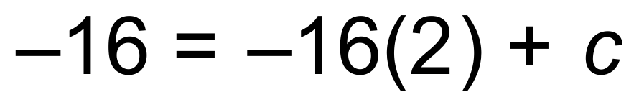
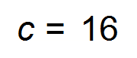
Tangent is 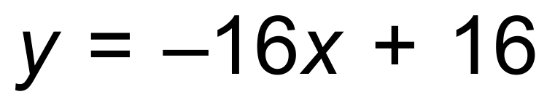 [11]

3. (a) 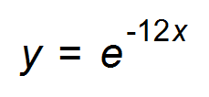
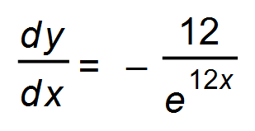
(b) 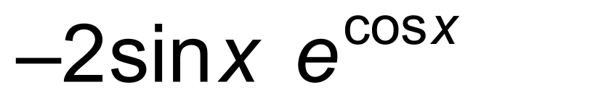 [4]

4. (a) The values of f(x) are all positive
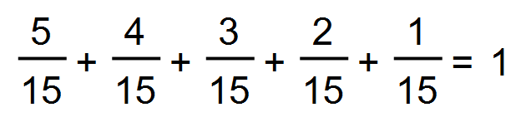
∴ Probability function
(b) 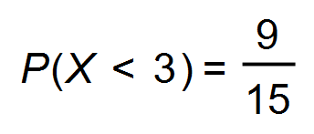
(c) 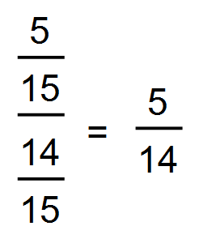 [5]

5. 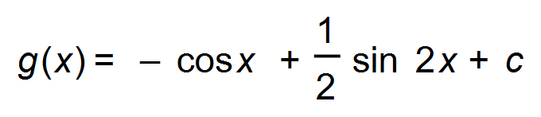
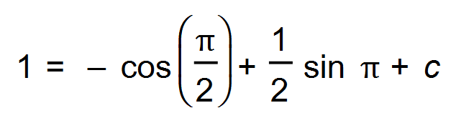
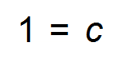
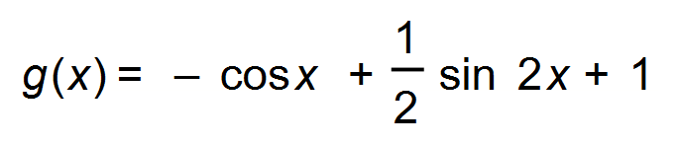 [3]

6. (a) 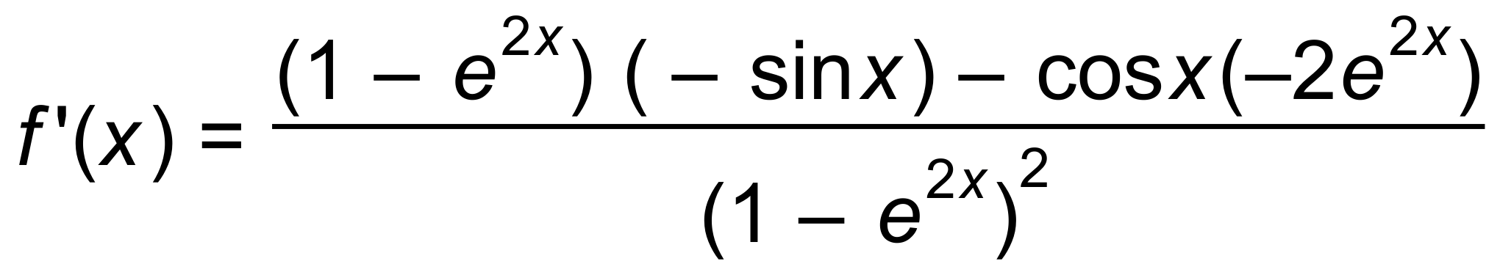
(b) 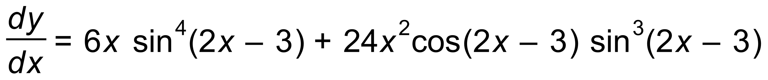 [4]

7. (a) (i) 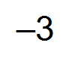
(ii) 6$+(-$2) = 4
(iii) 5 units²
(b) 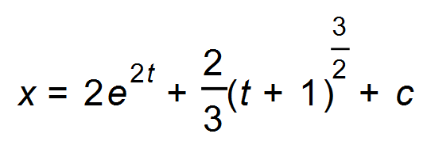
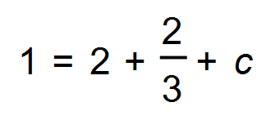
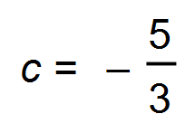
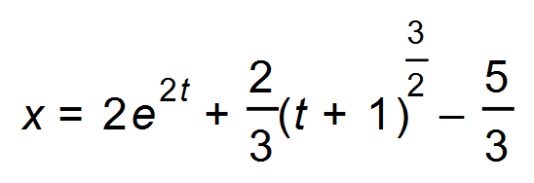 [8]

8. (a) 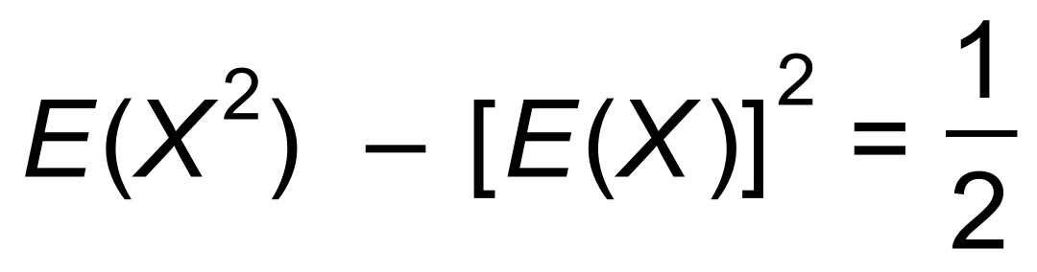
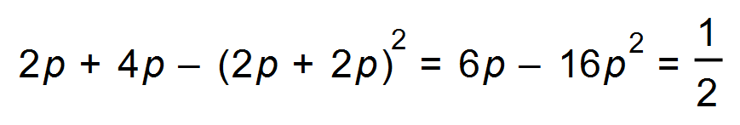
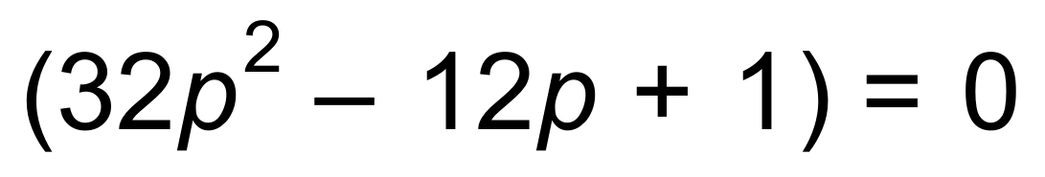
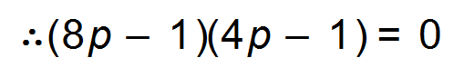
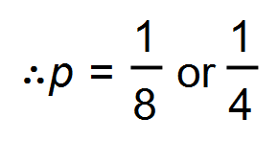
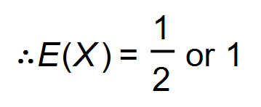
(b) (i) 21
(ii) Standard deviation of X = 3
|2| x 3 = 6 [7]

9. (a) 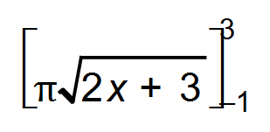
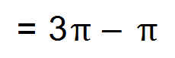 = 2π
(b) 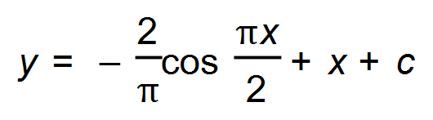
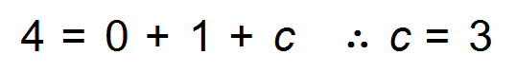
Its path is 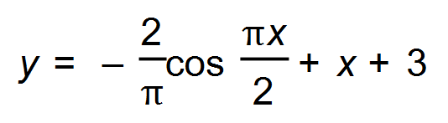 [5]

Calculator−assumed Solutions

10. (a) 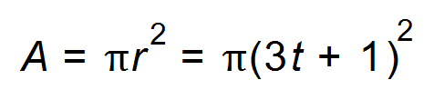
(b) 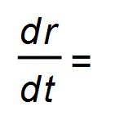3 cm/s
(c) 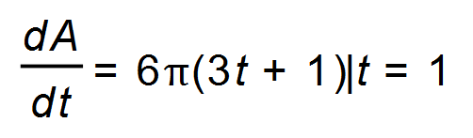
=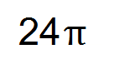 cm²/s
(d) 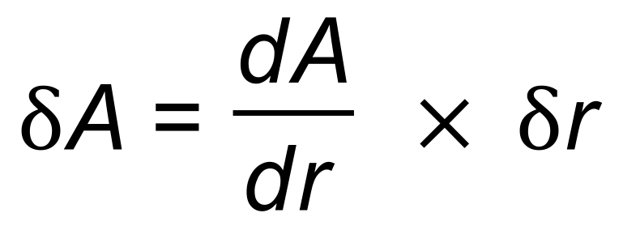
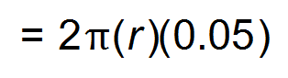
When r = 4 ,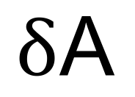 =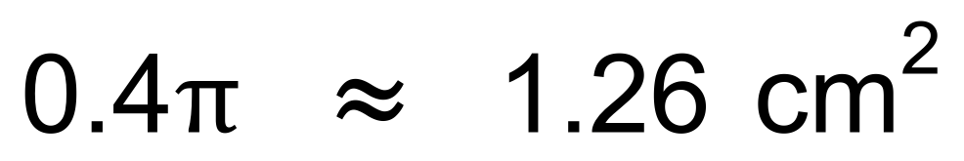 [6]

11. (a) Let P(X = 0) = k then 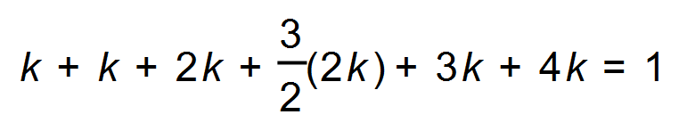
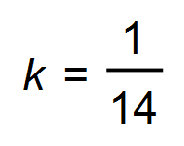

X | 0 | 1 | 2 | 3 | 4 | 5
P(X = x) | 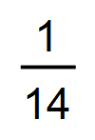 |  | 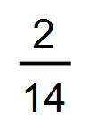 | 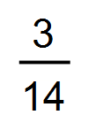 |  | 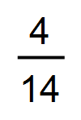
Frequency | 23 | 23 | 46 | 69 | 69 | 92

(b) mode = 5
mean = 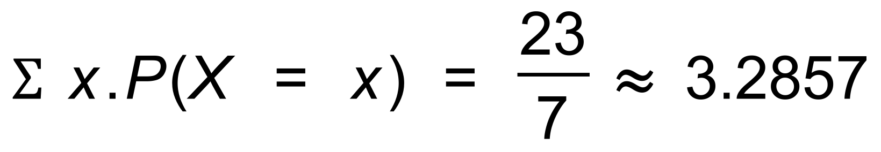
(c) 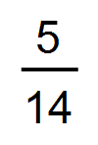 [7]

12. (a)
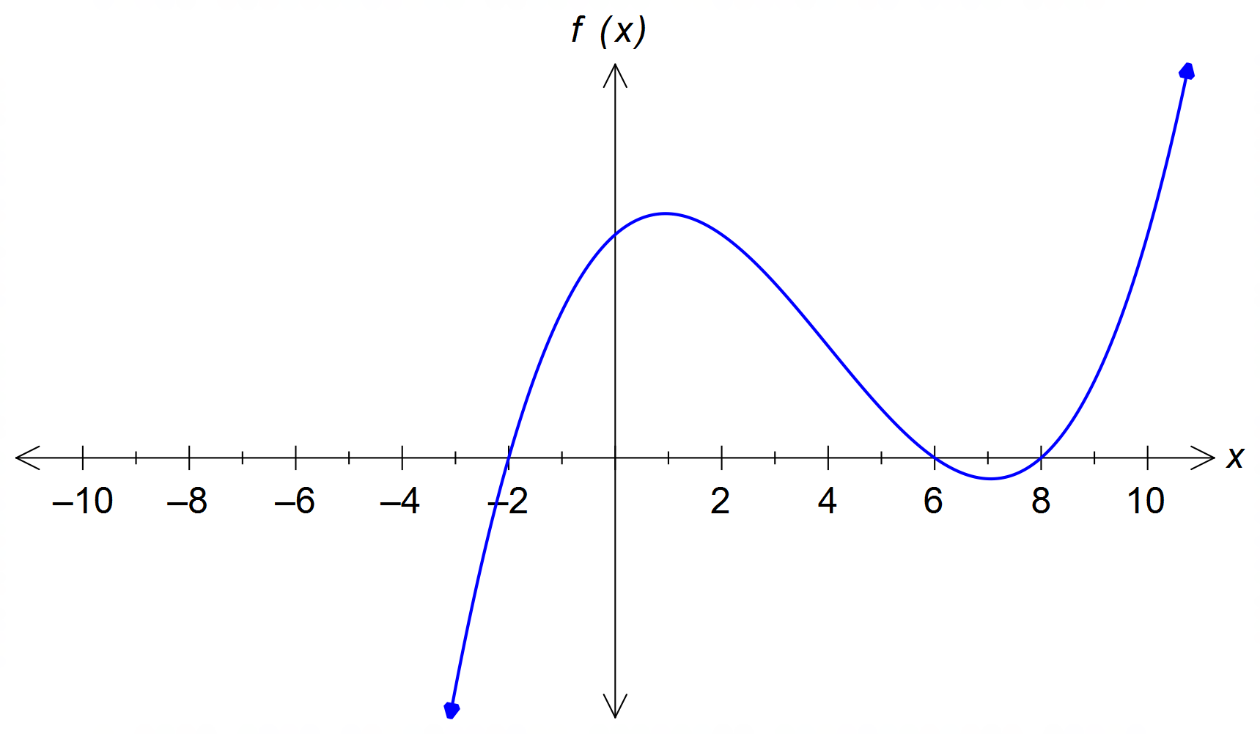

(b)

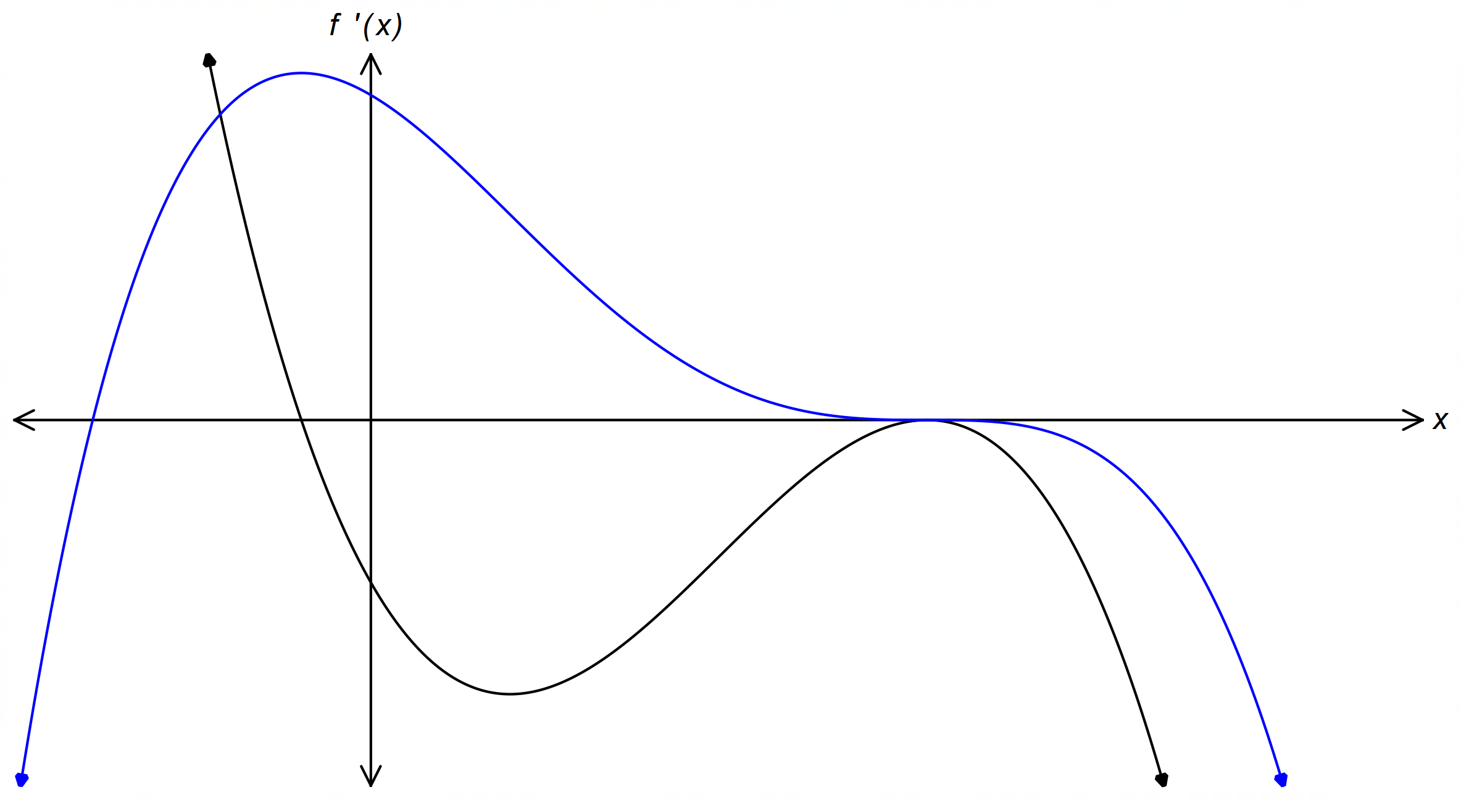

(c) 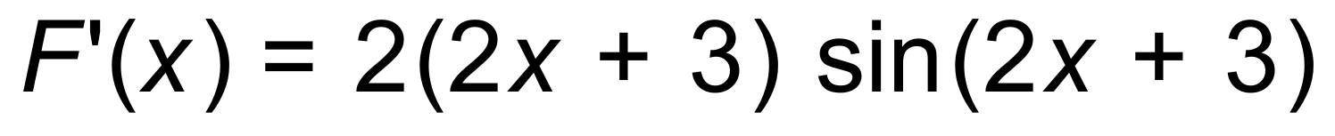 [6]

13. (a) 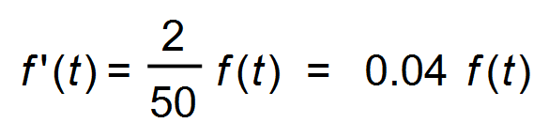
 k = 0.04
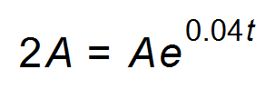
t = 17.3 days
(b) (i) 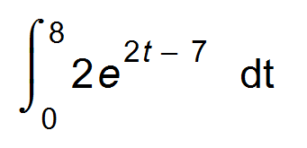= 8103.083 m²
(ii) 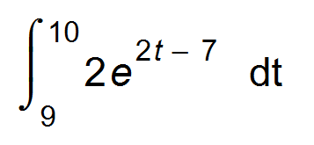 = 382 539.25 m²
(iii) The exponential growth of the area becomes too large
too quickly for the model to be realistic. [6]

14. (a) 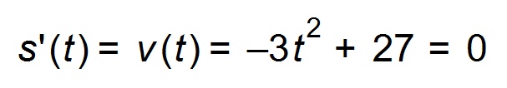
∴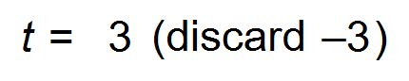
The maximum distance from O occurs at t = 3 seconds and
then the particle turns back towards O.
(b) 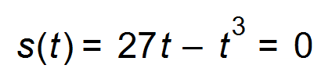
∴ 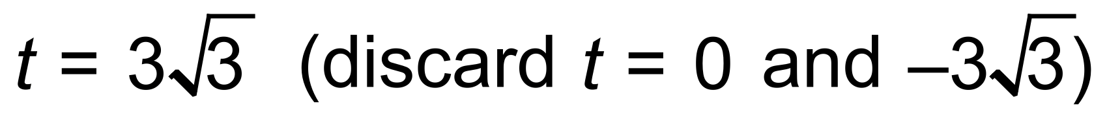
∴ 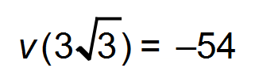
Therefore speed when the particle returns to O is 54 cm/s. [5]
15. 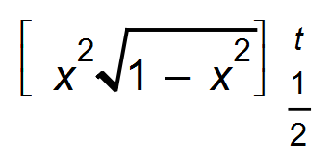 = 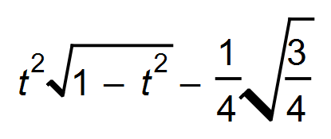
A(t)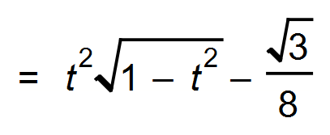 [3]

16. (a) Profit = Revenue $-$ Cost
(b) 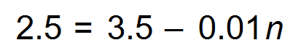
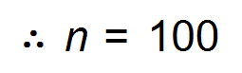 He will sell 100 figs
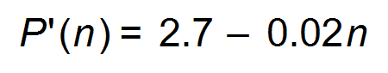 where n =100
The marginal profit is 0.7 = 70 cents [6]

17. (a) (i)
Y | 0 | 1 | 2 | 3
P(Y= y) | 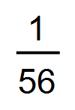 | 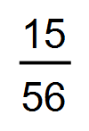 | 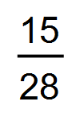 | 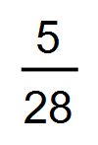

(ii) E(Y) = 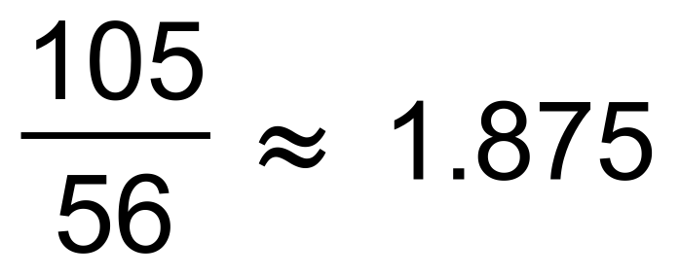
Var(Y) = 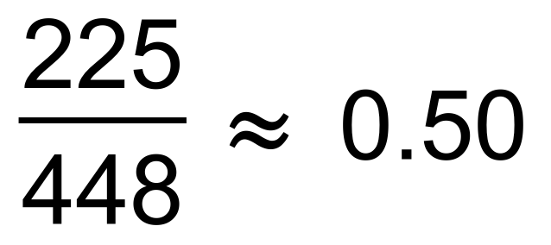
(iii) 
(b) (i) 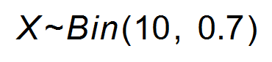
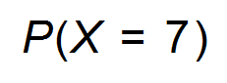= 0.2668
(ii) 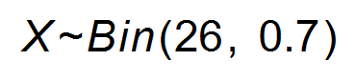
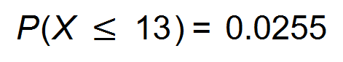
(c) 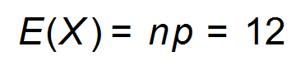
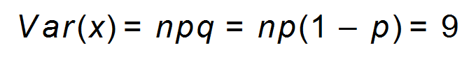
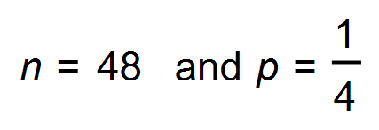 [10]

18. (a) The amount of water cannot be a negative amount.
If no water flows in or out the functions can equal zero.
(b) 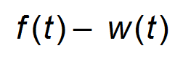 megalitres
(c) 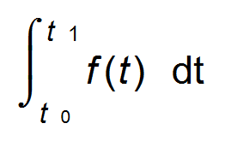
(d) 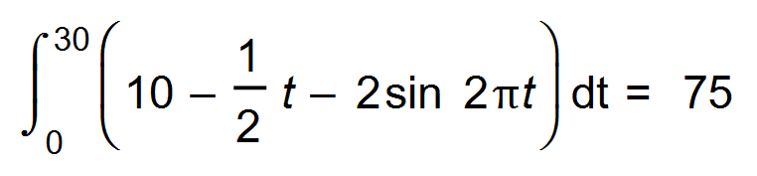
75 megalitres of water.
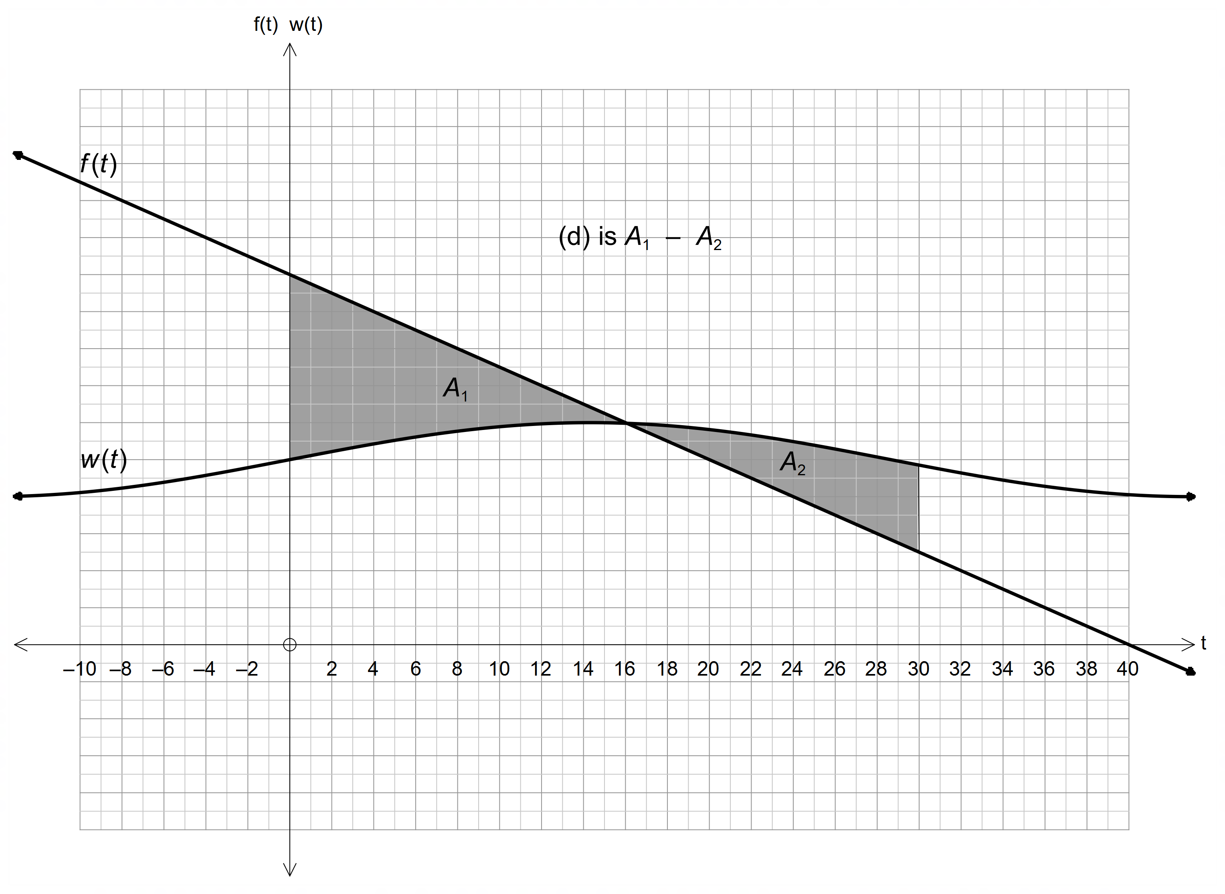
(e)

[8]

19. (a) (i) Each washing machine is an independent trial.
There are two outcomes: Success (a washing machine works)
and Failure (a washing machine is broken.)
(ii) E(X) = p = 0.2
Var (X) = p(1 $-$ p) = 0.2 x 0.8 = 0.16
Standard deviation = 0.4
(b) (i) This means that the first mobile phone was selected and found to be defective. (0 non-defective mobile phones were found)
P(X = 0) = 0.03
(ii) This means that the first two mobile phones selected
were found to be non-defective but the third mobile phone
selected was defective.
P(X = 2) = 0.97 x 0.97 x 0.03 = 0.028227
(iii) 0.97⁵ x 0.03 = 0.02576
(iv) 1 − [P(0) + P(1) + P(2)] = 0.91267 [12]

20. (a) 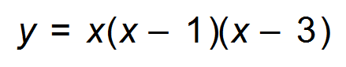
Graph cuts the x- axis at 0, 1 and 3.
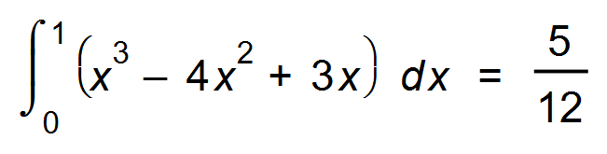
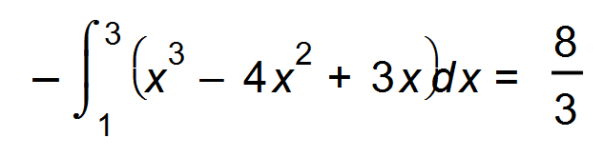
Area = 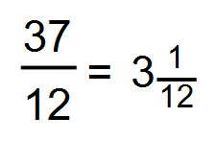
(b) 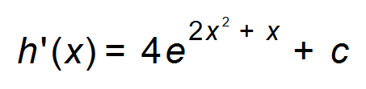
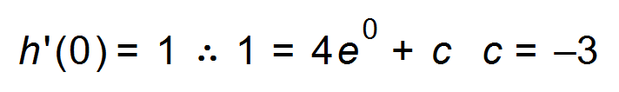
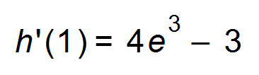 which is the gradient at x = 1
(c) Graphs intersect at x = 0.6349, 2.5067
= 2.5203 units² [9]
Or: 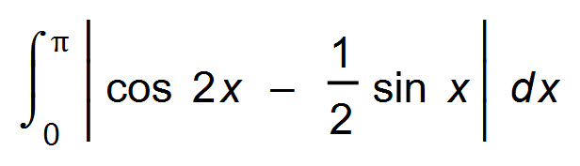= 2.5203 units²

21. In triangle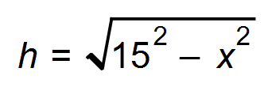 therefore A=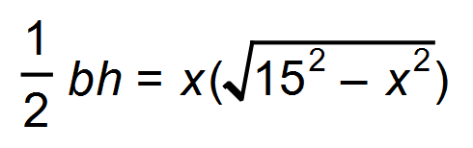
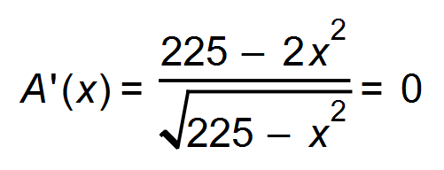
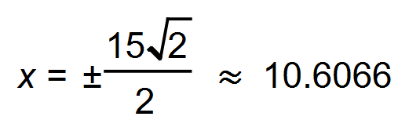 (Discard negative value for x.)
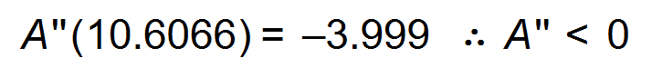 therefore maximum
Maximum area is 112.5 cm² [5]

22. (a) 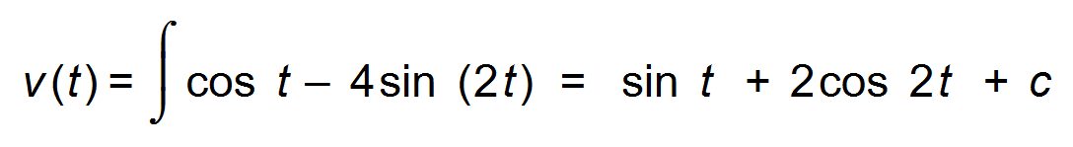
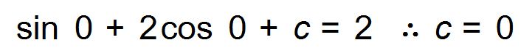
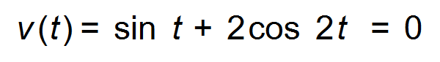
The particle changes direction when t = 1.003 s or t = 2.139 s
(b) 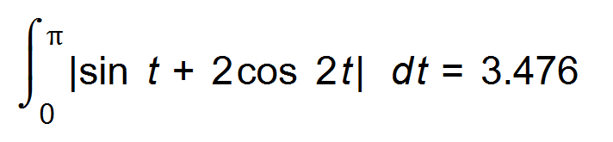m² [5]

23. (a)
g(0) | g(0.2) | g(0.4) | g(0.6) | g(0.8) | g(1)
1 | 0.96 | 0.85 | 0.70 | 0.53 | 0.37

Area from left = 0.2 (1 + 0.96 + 0.85 + 0.70 + 0.53) = 0.808
Area from right = 0.2 (0.96 + 0.85 + 0.70 + 0.53 + 0.37) = 0.682
Average = 0.745 = 0.75 units²
(b) As the width of the rectangle tends to 0,
the more accurate will be the area. [5]

24. (a) t = 110 years
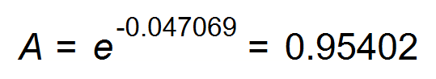grams
Therefore 4.598 % has decayed.
(b) 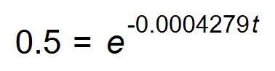
t = 1619.88 $≈$ 1620 years
(c) 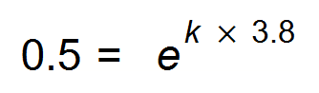
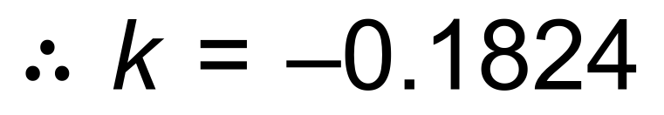
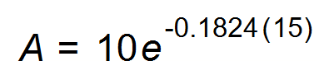
0.648 mg of radon remains [7]

END OF QUESTIONS

